RIBBON
The table everyone fits.
A single multi-height, chair-free communal table for every body, age, and use.

Business Plan
Confidential — for discussion purposes
August 2026 · Rev H.1 · Initial target region: Southern California / US West Coast
“RIBBON” is a working name. All financial and market figures are illustrative planning estimates (±30–40%), not quotes or guarantees.

Contents
1 · Executive summary
2 · The opportunity
3 · Product
4 · Market opportunity
5 · Competitive landscape & differentiation
6 · Business model & unit economics
7 · Go-to-market
8 · Operations & supply chain
9 · Technology & IP
10 · Sustainability, accessibility & impact
11 · Financial plan
12 · Risks & mitigations
13 · Team & organization
14 · Milestones

1 · Executive summary
RIBBON makes the first communal table designed to be used without chairs by fourteen people of any height, age, or mobility at once. A single sculptural surface flows through a range of working heights — from a toddler at 560 mm to a standing adult at bar height, with flat, knee-clear bays for wheelchair users — so a preschool, a museum, a family restaurant, and a coworking lounge can each seat their whole mixed-age crowd around one piece of furniture that also switches between social, dining/working, and hands-on activity modes.
The product is bespoke in feel but engineered for repeatable, digitally-fabricated, mass-customized production. A parametric model turns the wave into a small kit of standard height modules; a customer configurator drives fabrication directly; and a distributed “make-near-demand” supply chain keeps freight — the dominant cost for an object this bulky — low while preserving per-order customization.
We are targeting a beachhead in Southern California across education, museums and libraries, family hospitality, coworking, and senior-living operators — segments that genuinely need mixed-age, accessible, no-chair seating and that will stress all three use modes. The global contract-furniture market is large and growing (roughly 5% CAGR), with tables among its leading segments and modular, sustainable, and inclusive design as its strongest tailwinds.
The ask: a $1.75M seed round to fund an instrumented prototype, 3–5 pilot deployments, a first regional microfactory partnership, and a configurator MVP — 18–24 months of runway to Phase 2 production and Series A.

2 · The opportunity
Every shared table forces one height. Chairs paper over the mismatch — but chairs add cost, clutter, storage burden, and exclusion: a fixed-height table plus standard chairs serves a narrow band of adult bodies and quietly designs out small children, very tall people, and wheelchair users. Institutions increasingly want the opposite: flexible, collaborative, ergonomic, and inclusive spaces where mixed-age and mixed-ability groups gather.

Why now
- Flexible, collaborative layouts are displacing fixed rows of desks and chairs across schools and workplaces.
- Inclusive and sensory-friendly design is now an explicit procurement priority, especially in education and civic spaces.
- Ergonomics and wellbeing drive furniture as a strategic investment rather than a commodity purchase.
- Sustainability and circularity mandates reward modular, repairable, recyclable, low-carbon products.
- Multigenerational spaces — libraries, museums, senior living, family hospitality — need furniture that fits everyone at the same surface.

3 · Product (current state — Rev H.1)
RIBBON is a system of discrete, self-supporting ribbon segments — each a small table at one height, from a toddler's 560 mm to bar-height 1100 mm — that splice edge-to-edge into a Run: a Racetrack (≈3.9 × 1.2 m, ~10 segments), a Hex (2.65 m across flats, six segments, tessellates into clusters), or a Ring (Ø ≈2.95 m, eight wedge segments). Engineered seam pieces bridge every height change so a Run reads as one flowing surface, and every Run gathers around the Knot — a fixed focal segment on a load-bearing mast, typed at order as Planted, Service, Ice, or Solid, carrying the system's power and water internally.
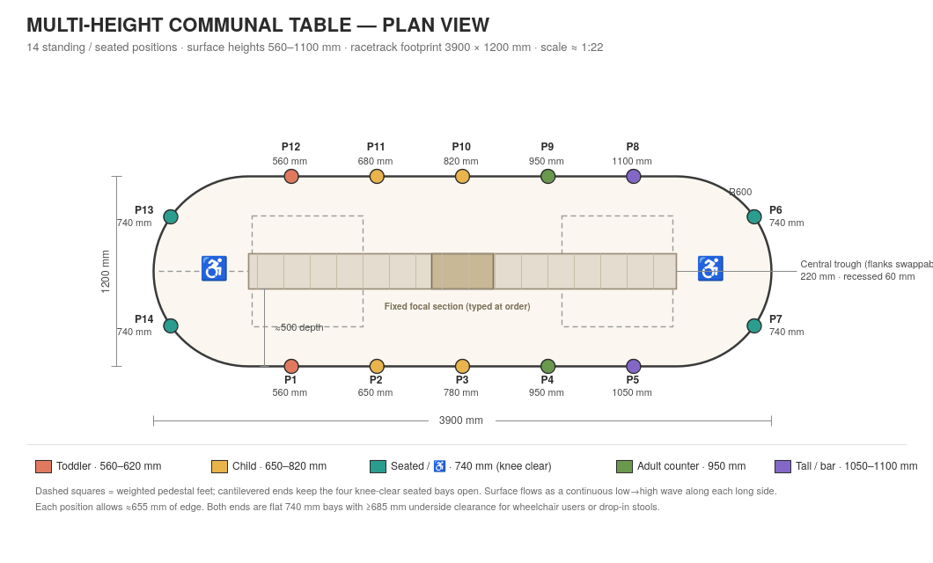
Racetrack Run — 14 positions with assigned heights; teal = wheelchair-first knee-clear bays; segments splice at the marked joints.

Why segments win
- Every body fits: fourteen positions at matched heights, four wheelchair-first 740 mm bays with full knee clearance — the wheelchair is the system's first and most honored chair.
- Ships like normal freight: stacked segment kits run ≈class 85 versus the retired monolith's ≈class 400 — the single largest economic unlock in the design.
- Grows and heals: venues start with three segments and add more; a damaged segment swaps in minutes; splices are tool-release, child-safe, and misdock-proof (spec B12/B13).

Modes, colorways, and seating
- Three modes live in the swappable layer — trough inserts and activity wells flip a Run between social, dining/working, and hands-on activity; the Knot is the committed heart.
- Five colorways (Cloud, Grove, Citrus, Slate, Custom) select per segment; a height-coded preset turns color into wayfinding.
- The optional AEL family adds level-matched seating that nests and yields — wobble perches for children, one true drop-in seat at the accessible bays, leaning perches at counter, stools at bar, never anything at the Knot. A Run is complete with zero AEL units: RIBBON needs no chairs.

Design history in one paragraph
The product began as a seamless multi-height monolith (Rev A–B), gained formal base requirements, colorways, and a fold variant (Rev C), circular and hexagonal geometries with fixed focal centers (Rev D), then made its defining pivot at Rev E — every level became its own table — followed by engineered transitions and full PRD governance (Rev F), the ribbon/table lexicon (Rev G), ratified optional seating (Rev H), and this consolidation (Rev H.1). Full trail: build spec appendix and the Master PRD Set.

4 · Market opportunity
RIBBON sits in contract (commercial/institutional) furniture — specifically the tables segment across education, hospitality, healthcare, civic, and workplace. Estimates of the global contract-furniture market vary widely by definition, but multiple 2025 analyses place it in the tens to low hundreds of billions of dollars, growing around 5% annually, with North America holding roughly 40% of demand and modular, sustainable, and customizable products cited as the leading growth trends.
Layer | Definition | Illustrative size
TAM | Global contract tables across education, hospitality, civic & workplace | ~$18–25B
SAM | North America communal / multi-height / accessible tables in our beachhead verticals | ~$2–4B
SOM (5-yr) | Obtainable share of the SoCal + West-Coast beachhead | ~$20–50M

Anchor reference points behind these figures: the US school-furniture market alone was ~$2.1B in 2024–25 (growing ~6% annually) across ~98,500 public and ~30,500 private schools, and global educational furniture was ~$5–9B in 2025 with North America ~34% of it — and that is only one of our verticals. Museums and libraries, family-style hospitality, coworking, and senior-living operators add materially to the serviceable base.
Sources: contract- and education-furniture market reports (SkyQuest, Grand View, GM Insights, Fortune Business Insights, Future Market Insights, The Insight Partners, 2025–2026). Figures are ranges; TAM/SAM/SOM are our derivations, not vendor numbers.

5 · Competitive landscape & differentiation
Incumbents — MillerKnoll, Steelcase, Haworth, KI, Kimball, and education specialists such as Paragon — compete on modular, ergonomic, and increasingly sustainable furniture. But their catalogs still assume the chair: adjustable desks solve one person's height, not fourteen people's at one shared surface, and none pairs a single mixed-height, chair-free, all-ages, mode-switching, accessibility-first table with a parametric configurator and distributed make-near-demand production.

Our defensible edge
- Category of one: a communal surface that fits a toddler, a standing adult, and a wheelchair user at the same table without chairs.
- Mass customization: a parametric height mix and insert set, sold through a configurator that feeds fabrication directly — custom feel at production margin.
- Supply-chain design: distributed regional fabrication turns the product's bulk (a rival's cost problem) into our freight and speed advantage.
- Accessibility & sustainability as standard, not upsells — a genuine advantage with public and institutional buyers.

6 · Business model & unit economics
Primary revenue is make-to-order table sales at a blended ASP of ~$7,500 (entry configs from ~$6,500; premium/large from ~$12,000). Gross margin climbs from thin at pilot scale — where one-time engineering is absorbed — toward ~50% as the kit-of-parts, jigged assembly, and distributed build take hold. Secondary streams compound the model:
- Inserts & modes: trough kits, activity-well sets, and refresh modules — recurring, high-margin attach sales.
- Design licensing: license the parametric design to regional fabricators as we expand — asset-light geographic scaling.
- Service & circularity: takeback, refurbishment, and single-module upgrades — the flat/modular architecture makes these cheap and sticky.
Because production is make-to-order and the parametric file is effectively the inventory, we hold almost no finished-goods stock — critical for an oversized product.

7 · Go-to-market
We land in one metro (Southern California) where beachhead demand is dense and a deep base of millwork, solid-surface, and metal-fabrication shops can serve as our first microfactory. The motion: instrument a flagship prototype, convert 3–5 lighthouse pilots (a school, a children's museum or library, a family restaurant, a coworking or senior-living site), then use those references and usage data to sell into the surrounding region before replicating the pattern city by city.
- Channels: direct to institutions and architects/designers (spec-driven sales), plus dealer and GPO/procurement pathways for education and civic buyers.
- Proof: pilots double as R&D — utilization by zone, comfort, cleanability, and accessibility data that de-risk both the product and the next sale.

8 · Operations & supply chain
Production scales in four phases. The cost curve is driven by tooling amortization (Phase 0→1), then labor per unit (1→2), then freight and mold elimination (2→3) — beyond Phase 2, geography, not the shop floor, is where the money is.
Phase | Volume | Goal & process | Unit cost* | Lead time
0 Prototype | 1 | Prove ergonomics; parametric model; 5-axis CNC; instrumented 14-person test | $12–20k | 8–16 wks
1 Pilot | 10–50 | Repeatability & cost; reusable molds + jigs; DFMA + flat-pack; configurator→CAM | $4.5–7k | 4–8 wks/unit
2 Production | 100–500/yr | Modular kit-of-parts; jigged/contract assembly; make-to-order | $2.8–4k | 3–5 wks/unit
3 Distributed | 1,000+/yr | Robotic finishing; LFAM near-net top; digital thread; regional microfactories | $2–3k ex-works | 1–3 wks
*Fully-loaded ROM, ±30%.

Make / buy / print by volume
Part | Prototype | Pilot | Production | Mass
Top skin (solid surface) | Make — mold | Make — mold | Make — tooled | Print — LFAM
Top core (ply/bamboo) | Make — CNC | Make — CNC | Make — CNC | Make / n.a.
Steel spine | Make — weld | Make — jig | Buy to file | Buy — robotic
Base plates | Buy to file | Buy to file | Buy to file | Buy — hub
Trough liner (316 SS) | Buy to file | Buy to file | Buy to file | Buy — volume
Trough inserts / lids | Print | Print | Buy — mold | Buy — mold
Activity tubs (HDPE) | Buy — OTS | Buy — OTS | Buy — molded | Buy — molded
Hardware / glides / footrail | Buy | Buy | Buy | Buy

Two print stories run in opposite directions: small complex inserts are printed early for variety then tooled once volume pays for molds, while the largest part — the top — shifts to large-format additive at scale to kill tooling cost and re-enable true per-order geometry. Everything flat, dense, and standard (base plates, trough kit, hardware) stays buy-to-print and is the right thing to centralize.

Factory model: distributed-leaning hybrid (recommended)
The economics point away from one central mega-plant. RIBBON is bulky, heavy, high-mix, and — early — low-volume-per-site with dispersed demand: attributes that all favor building near the customer. Long-haul, oversized freight on an assembled 3.9 m table often exceeds the marginal fabrication a good regional shop gives up, so the crossover favors distributed until volume is both very high and geographically concentrated.
The rule: centralize the flat, dense, standard, low-mix parts (base plates, trough kits, hardware) at one or two hubs and ship them compact; distribute the bulky top and final assembly to regional microfactories via licensing or on-demand networks. Southern California's dense fabrication base, port access, large beachhead demand, and sustainability-minded buyers make it an ideal first node — with no new plant required.

9 · Technology & IP
- Parametric design engine (Rhino/Grasshopper or Fusion) — heights and modes are variables, so every market and order is a re-tune, not a redraw.
- Configurator → digital thread: customer choices drive CAM directly and serialize each unit with a digital twin — mass customization with no manual CAD step.
- Future processes: large-format additive (recycled pellet) for near-net tops, generative design for a minimal-material base, and material passports enabling takeback.
- IP: design rights on the wave/module system, the accessibility-first bay geometry, and the configurator; controlled toolpaths and serialized files protect licensed production.

10 · Sustainability, accessibility & impact
Inclusion is the product, not a feature: one surface that fits small children, tall adults, and wheelchair users at the same table. On sustainability, the flat, modular, digitally-fabricated architecture that lowers freight also makes the table repairable, upgradeable one module at a time, and recyclable — supported by low-VOC finishes, recycled/bio-based and low-carbon materials, and a takeback loop. Both map directly to institutional procurement priorities and public-buyer bid criteria.

11 · Financial plan
Unit basis (Rev H.1): costs are stated per ribbon segment; pricing per Run — a standard Racetrack Run of ~10 segments plus the Knot and seam set sells at the ~$7,500 blended ASP, so the volumes below are Runs. The illustrative five-year trajectory follows the production phases: pilots and R&D in Years 1–2, production ramp in Years 3–4, and distributed scale (plus licensing) in Year 5. Margins expand as one-time engineering is absorbed and the kit-of-parts and distributed build take hold.
Year | Runs | Revenue | Gross margin | EBITDA
Y1 | 15 | ~$0.11M | ~12% | ~ (0.7M)
Y2 | 120 | ~$0.9M | ~30% | ~ (0.8M)
Y3 | 450 | ~$3.4M | ~42% | ~ (0.2M)
Y4 | 1,100 | ~$8.5M | ~48% | ~ $1.0M
Y5 | 2,600 | ~$20.5M | ~52% | ~ $3.2M
Illustrative planning model at ~$7,500 blended ASP per Run (Rev H.1 basis); ±30–40%. Not a forecast or guarantee.

Locked assumptions (Rev B)
Working decisions taken to move into execution; each remains reversible.
- Name: RIBBON (working name, pending trademark clearance).
- Initial region: Southern California / US West.
- Pricing: ~$7,500 blended ASP; gross-margin target ~50% at scale.
- East node: North Carolina Piedmont (High Point/Triad); Atlanta as alternate.
- Structure: own the West anchor and first central parts hub; license regional nodes from the national stage onward.
- Funding: raise the $1.75M seed rather than bootstrap the pilots.
Reconciled with the companion crossover model: under base assumptions a regional finishing node breaks even near ~237 units/yr, and distributed nodes run ~47% gross margin versus ~40% centralized after freight — reinforcing the distributed-leaning build.

The ask & use of funds
Raising a $1.75M seed for 18–24 months of runway — through prototype, pilots, first microfactory, and configurator MVP — to reach Phase 2 production and a Series A.
Use of funds | % | Amount
Product & tooling engineering | 30% | $525k
First microfactory partnership & pilot builds | 25% | $440k
Configurator + digital-thread MVP | 18% | $305k
Go-to-market & beachhead sales | 15% | $260k
Working capital & contingency | 12% | $220k

12 · Risks & mitigations
- Freight / logistics on an oversized product — mitigate with flat-pack knock-down design and distributed make-near-demand.
- Quality consistency across independent shops — mitigate with the digital thread, fixed CAM, jigs, and QA gates.
- Long institutional sales cycles — mitigate with lighthouse pilots, GPO/dealer channels, and architect specification.
- Cost/maturity of large-format additive — treated as upside, not a dependency; mold-based production carries Phases 0–2.
- IP leakage under licensing — serialized files, controlled toolpaths, and staged disclosure.

13 · Team & organization
[To be completed.] Target founding coverage: industrial/furniture design and DFMA; computational design and software for the parametric configurator and digital thread; and operations/supply-chain leadership with contract-manufacturing and institutional-sales experience. Near-term hires align to the seed milestones above; a design-and-fabrication advisory bench and accessibility consultants round out early governance.

14 · Milestones
- 0–6 mo: instrumented flagship prototype; parametric model; first fabrication partner signed.
- 6–12 mo: 3–5 lighthouse pilots live; configurator MVP; validated unit cost and DFMA/flat-pack.
- 12–24 mo: Phase 2 production in-region; first licensing conversations; Series A.
- 24 mo+: replicate microfactory pattern metro-by-metro; introduce LFAM tops and takeback loop.

Appendices available separately: plan-view drawing, one-page build specification, and the productionization playbook (phased roadmap, make/buy/print sourcing matrix, and factory-model brief).

